**For the Phone view.**

In the above website. I found out that in the phone view, there is only the search bar at the top, an icon at the top left named **“IN”**, another icon on the top right conner of the website.

It also has a navigation at the top right conner that when clicked on, will give a statement that says, **“Report this Profile”** and other things like the logo or image, the name of the website and what they do, an activity image and a selection bar with the blue background.

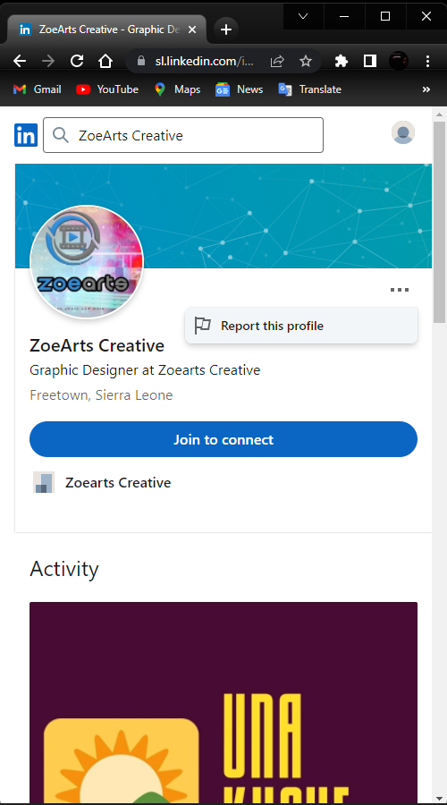

**For the tablet view.**

In This view, features like the sign in option, to sign in with Google, to join now or you’re to sign out.

You can also see another tiny icon named **“Zoearts Creative”.** Also, a text on a post that says **“Una Kushe”.**

The tabs at the top also adding features like Zoearts, Creative, People with a drop down for a Job or Learning, a search bar, and a sign in option at the top right conner to join immediately.

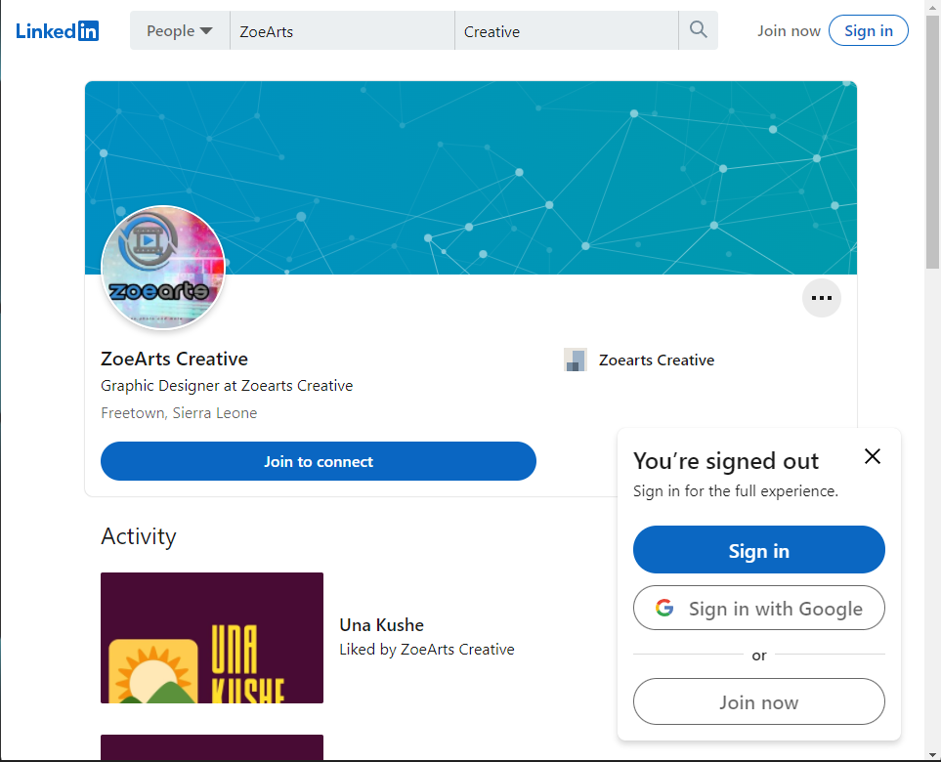

For the Desk-top view.

More features like, images of different this done by the website. You’ll be able to see all courses, view the profile badges, a “Link in” icon, a large view of the website that you can see all features of the website.

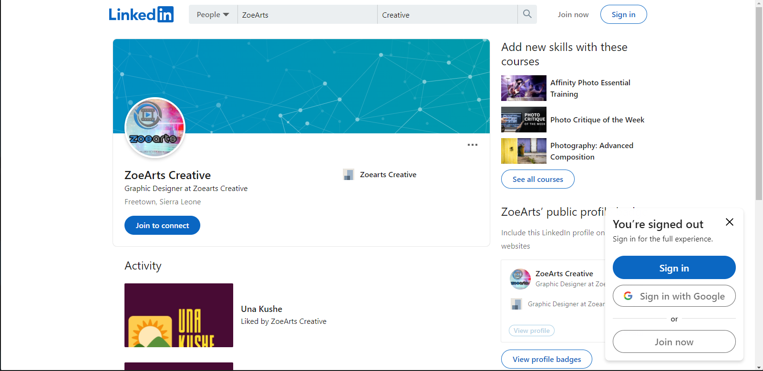

**Link**: [**https://sl.linkedin.com/in/zoearts-creative-87406321a**](https://sl.linkedin.com/in/zoearts-creative-87406321a)